**Board Briefs**

**May 2024**

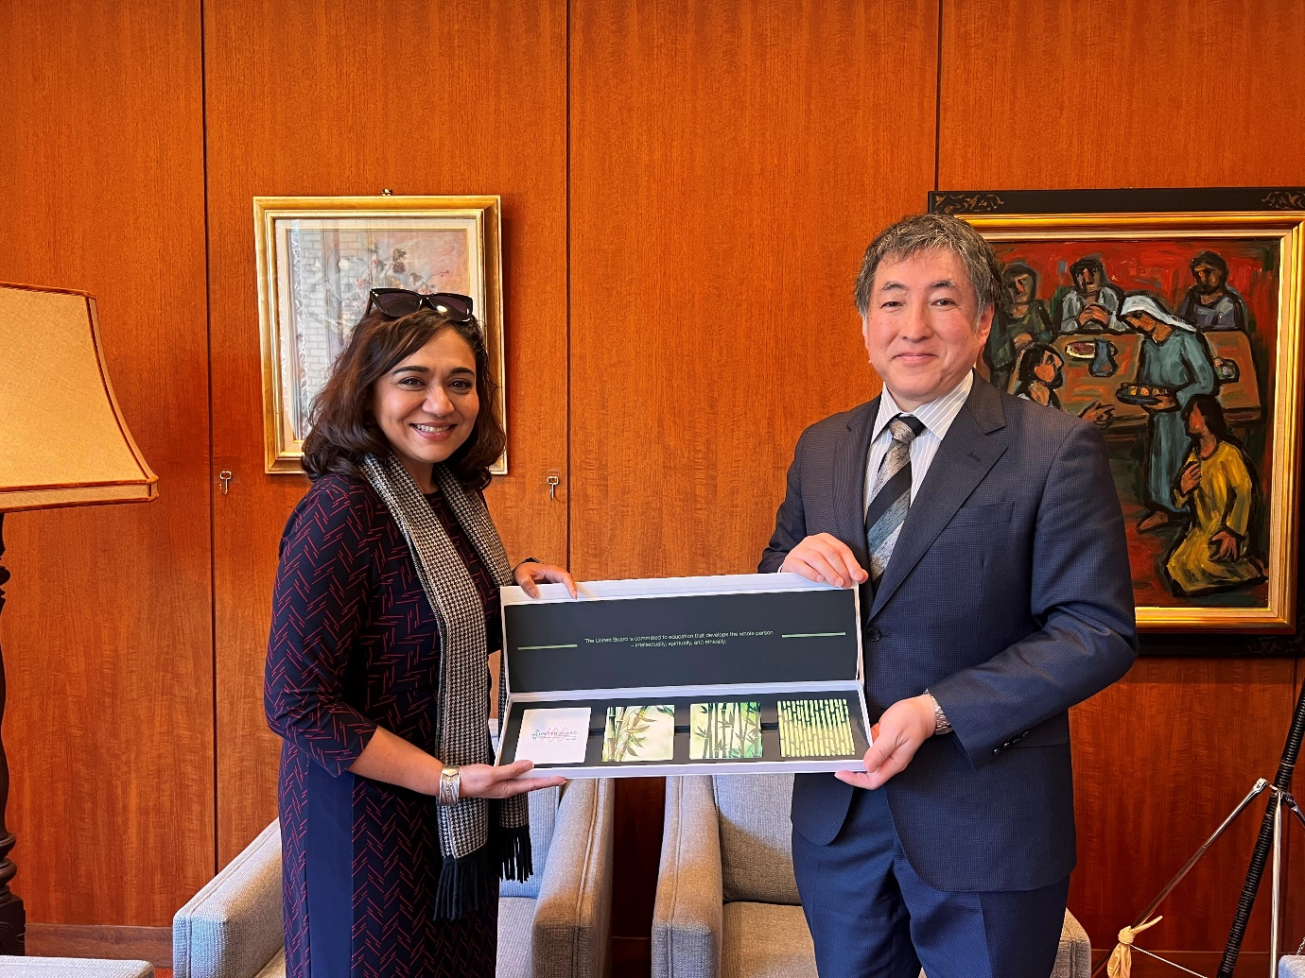

Dear Trustees,

I'm pleased to share some important updates with you since the last *Board Briefs* in March.

First, I will report on my visits to higher education institutions and a foundation in the Philippines, Japan, and Bangladesh. These trips were invaluable in strengthening our understanding and collaborations with these institutions. I was impressed by, among others, the institutions’ commitment to student learning and community engagement and social action, and how much we share in common on advancing higher education in Asia.

Closer to home, we recently conducted a survey to better understand your perceptions of our communication channels and meeting materials. Thank you for your responses. While the results indicate a high level of satisfaction with the existing channels and amount of meeting materials, we've also identified a few areas for improvement. I invite you to look at the results in the following pages and provide me with further comments and advice.

Our ongoing staff development initiative is beginning to bear fruits. Through a series of workshops and individual coaching sessions, we've been working to enhance the skills and capabilities of our colleagues across the offices as well as those in directorial positions. The feedback from our staff has been overwhelmingly positive, and we excerpt for your reference the reflections from Tommy and Jakarin on their journeys so far.

In other news, Ricky recently gave a well-received presentation on fundraising strategies to university leaders in Indonesia. Ricky’s is an ongoing service in our resource development efforts to bring a culture of giving to the Asian countries we serve.

Finally, I'm delighted to announce that we will be welcoming a new Education Technology Officer to our team. Mr. Christian Aung will be responsible for spearheading our efforts to integrate cutting-edge digital tools and platforms into our programming. We’re also in the process of recruiting a Program Associate to take charge of the setting up an alumni-serving function.

As always, I'm grateful for your continued support and guidance. I look forward to meeting you in person at our Board meeting and study tour in Indonesia next month.

Pareena Gupta Lawrence

President, United Board

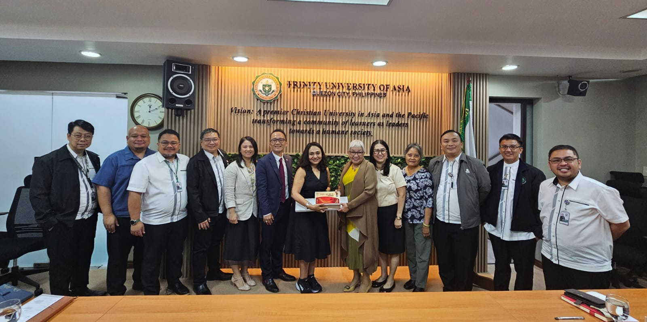

**Three Countries in Two Months**

In February, I went with Hope, Jakarin, and Rachel to the Philippines to visit our partners to deepen mutual understanding and further collaboration. On 27 February, at **Ateneo de Manila University** (AdMU), a longtime collaborator and the host of our leadership academy, we were received by President Fr. Roberto C. Yap, SJ and his management team. We also met with the dynamic teams of AdMU’s SALT Institute and Ateneo Teacher Center, and were treated to a tour of the beautiful campus at Loyola Heights for a glimpse of the vibrant student life at AdMU.

At the **Trinity University of Asia**, President Gisela de Asas-Luna shared with us their best practices and how their leaders applied what they learned from United Board programs. At **St. Scholastica’s College**, we learned about women empowerment and their transition into co-education, as well as the sisters’ inspiring stories on their leadership journey. At **De La Salle University**, we were no less impressed by their strong program on social entrepreneurship.

In March, Ricky and Jakarin joined me in a trip to Japan. On 11 March, we were received by President Tomoko Ueki and her team at **Doshisha University** in Kyoto. Among the topics discussed was campus ministry that supports students’ mental well-being. The meeting was both productive and inspiring, laying the foundation for further cooperation and partnership.

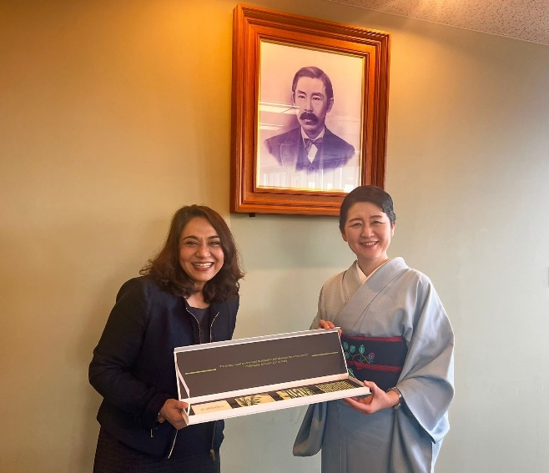

On the same day, we also paid a visit to **Kwansei Gakuin University** in Osaka and met with Chancellor Motoo Nakamichi and other senior officers. Our discussions centered on the challenges and opportunities for Christian higher education and the United Board’s offerings in terms of faculty and leadership development. We reaffirmed our already strong connection and identified potential avenues of cooperation.

We continued in Tokyo with a visit to **Wesley Foundation**, our partner in women leadership in Asia. We met with their Director/CEO Ms. Hikari Kokai Chang, and we exchanged ideas on promoting social entrepreneurship and community engagement.

In the afternoon, we were happy to reunite with former trustee Dr. Anri Morimoto and president of **Tokyo Women’s Christian University** (TWCU) and learned about the challenges facing private Christian universities in Asia. We were pleased to learn that TWCU will be expanding their exchange partnerships with colleges and universities in India.

On 13 March, we visited **International Christian University** and met with President Shoichiro Iwakiri and members of his management team. Our last stop in Japan was **Sophia University**, another partner institution that has hosted our Fellows. The discussions with Vice President for Global Academic Affairs Prof. Tetsuo Morishita centered on the sustainable development goals and the importance of grooming global leaders.

From 18 to 20 March, Spurgeon and I went to Bangladesh and paid a visit to the **Asian University for Women** (AUW). Our conversations with the Vice Chancellor, the founder, officers, faculty and students of AUW were most rewarding, and we were also taken on a tour of their new campus under construction.

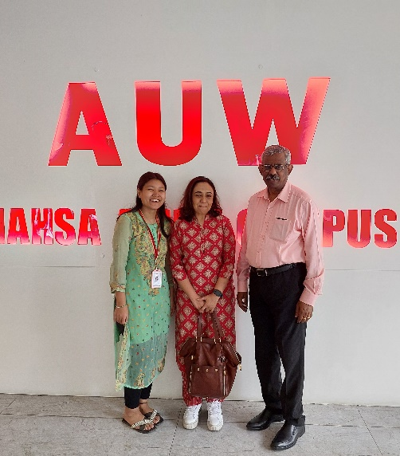

All in all, I can say that such encounters were opportunities to have in-depth exchanges with the key persons in higher education as we refresh our existing programs and design new ways to help strengthen Christian higher education in these regions. I have also reaffirmed to them that the United Board will continue to be their steadfast partner in exploring opportunities and navigating challenges in higher education.

**Trustees Survey on Communication Channels and Meeting Materials**

A survey on communication channels and meeting materials was sent to the Trustees on 29 February. By mid-March, 12 Trustees (80%) had responded.

The survey comprises 10 questions aiming to solicit Trustees’ views on the existing communication channels, and the frequency and materials for the committee/Board meetings.

From the survey results, the vast majority of Trustees rely on the Trustees Updates (now *Board Briefs*) for information about the United Board. For social media, about half of them use LinkedIn and Facebook.

As to the frequency and adequacy of information of the different channels (*Horizons*, website, etc.), the majority of Trustees think it appropriate (83.3%). The same can be said for the frequency and adequacy of information for the committee meetings.

When it comes to the volume of Board materials, while the majority of respondents think it’s appropriate (75%), 25% think it’s “too much [and] difficult to review and digest”. When asked about what they prefer the materials to be, a greater percentage of them (41.7%) chose “more concise, focusing on key information”.

Trustees also provided comments which can be divided into the categories of general communication, committee/Board meetings, and Board interaction.

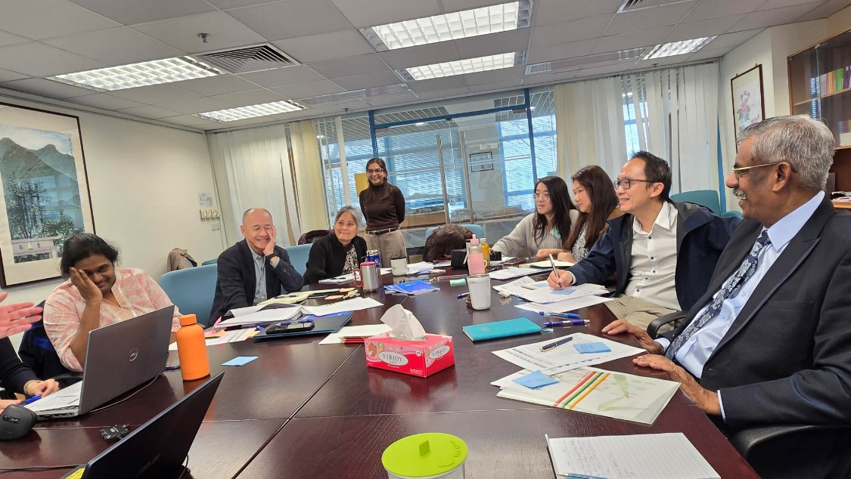

**Staff Development**

**Reflections from Staff Members**

“If life is a path which forks and bifurcates at different points where one closes a gate and goes down one tributary, then one takeaway from the staff development exercise led by Open Consulting is the realization that one can always backtrack, unhinge closed gates and tread down alternative routes to see new landscapes and reach new frontiers. The means with which to do so, made available by the consultants, include “downloading” (putting aside received ideas to make space for new ones), empathy walks and stakeholder interviews (emotional engagements with co-workers). Unhinging gates and going down routes not taken before are not only meaningful and productive, but, taken together by different actors in pursuit of common goals, also forge a collective identity and unlock and augment the sum potentials of the actors.

“As the exercise is still ongoing, I’m very much curious to see what it would do to the esprit de corps of the teams in six months, in a year, and beyond.” (*Tommy Cho, Director of Communications)*

“Participating in staff development programs has facilitated connection with colleagues, providing insights into our collective challenges. These interactions fostered personal growth and a deeper understanding of our shared experiences. Through sharing sessions, I recognized how past experiences influenced my collaboration skills, leading to stronger relationships with colleagues and a greater sense of unity.

“Working on group assignments, such as the Vision and Mission project, strengthened these connections by promoting open dialogue, idea sharing, active listening, and teamwork among the senior management team.

“In conclusion, staff development initiatives have encouraged personal and professional growth, bridging gaps, and nurturing camaraderie. These experiences have invigorated our commitment to the organization's values and purpose, empowering us to better serve our mission and contribute to the advancement of Christian higher education in Asia.” (*Jakarin Scrimoon, Director of Leadership Development)*

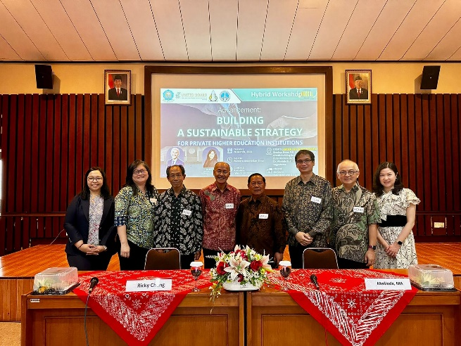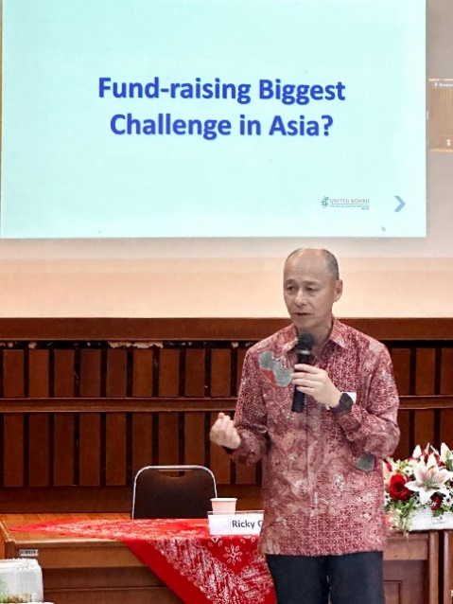

**Advocating for a Culture of Giving in Indonesia**

On 26 March, Ricky, a seasoned advancement professional, delivered a workshop titled “Building a Sustainable Strategy for Private Higher Education Institutions” at Duta Wacana Christian University in Yogyakarta, Indonesia.

The workshop attracted 50 senior leaders from the region, many of whom coming from afar. Ms. Raynesta M. Indri Malo is the head of the advancement office at Unkriswina Sumba. She took the plane from Sumba, a small island, to Yogyakarta via Bali. She was appreciative of the knowledge and practical solutions shared by Ricky, as well as, in her words, “the encouragement given us to start something, even if it is a small step for advancement.”

Coming from Kupang, the Rev. Mesach Daniel Beeh, founder and general chairman of the Foundation of Artha Wacana Christian University, said, “I do appreciate this workshop that strengthens our unity and willingness to pooling and sharing our resources as Christian higher education institutions.”

Mrs. Dewi Kumalasari, S. Si., head of the Protocol Unit of Krida Wacana Christian University, agreed: “I have learned that we have to find out the uniqueness of our institutions and use it as our advantage in working together with related units for the betterment of the university. I also realized that we need to dream big and persevere in order to achieve our mission.”

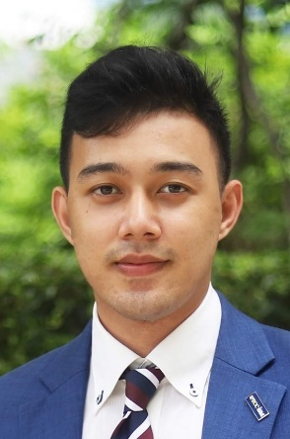

**Staffing Updates**

Mr. Christian Aung will be joining the United Board soon as Education Technology Officer. He will be tasked with developing and executing a strategic plan for the incorporation of AI and other advanced Educational Technologies (EdTech) into the organization’s initiatives, aligning with its key priorities. Christian will work closely with team members, network institutions, and grantees to ensure the successful implementation of EdTech programs, facilitate faculty development in AI and hybrid learning, and promote lifelong learning opportunities.  
  
Christian had served as Head of Marketing at German Standard and was previously an Academic Coordinator at Harbour.Space University of the Thai Chamber of Commerce, after leading ASEAN Programs at the same institution. He holds an MBA in Digital Marketing from Harbour.Space and an MBA in Entrepreneurship from the University of the Thai Chamber of Commerce, where he also completed his BBA in International Business Management.

**Schedule for Board Meeting and Study Tour in Yogyakarta, Indonesia in June**

**[TBC]**